### George Brown College

### 

### 

### 

### 

### 

### 

Swipe Survivor: Game Design Document

### 

### Version #8

### By: Vincent Ho

### 

### Table of Contents

### 

**Version History (Document)** **3**

**Version History (Game)** **3**

**Detailed game Description** **3**

**Mechanics** **3**

Camera 4

**Controls** **4**

Gameplay 5

Game Over 6

**Screen Descriptions & Screenshots (Updated)** **6**

**Game World** **7**

**Levels (Updated)** **8**

**Characters** **8**

**Enemies (AI) (Updated)** **8**

**Weapons:** **9**

**Scoring:** **9**

**Art/Multimedia Index (Raw files of images):** **9**

### 

### 

### **Version History (Document)**

* Ver. 1: Filled general outline of the document, listing the basic details of the detailed description, controls, game world, characters, weapons, scoring, and art/multimedia index
* Ver. 2: Added basic descriptions for the basic level, goblin/ogre and turret enemies listed
* Ver. 3: Removed analog pad from controls section. Focusing on strictly touch movement
* Ver. 4: Created interface sketches and implemented them into the document
* Ver. 5: Added a logo and a basic table of contents
* Ver. 6: Added the player and enemy sprites into the document
* Ver. 7: Implemented screenshots of the game
* Ver. 8: Updated interface sketches
* Ver. 9: Cleaned up out-of-scope items such as the weapon switching
* Ver. 10: Updated Sound index
* Ver. 11: Updated in game screenshot
* Ver. 12: Updated Art/Multi-media index

### **Version History (Game)**

* Movement enabled via touch and drag
* Item ScriptableObject workflow, create a ScriptableObject of PickupItem, fill with data such as item type and variable values, then paste it in the Item script.
* Enemy object pooling working
* Enemy AI for Ogre created, player detection and rotating to face player
* Bounce Enemy Behaviour implemented
* Turret always targeting player
* Item Object Pool works, can now spawn random items in the level
* Enemy AI for Ogre will patrol random points in the level, chase player if player falls within range
* Score over time added
* Timer appropriately working
* Score from coin pickups and killing enemies working
* Implemented Sound Effects

### **Detailed game Description**

You are a lone warrior trapped in an arena pit. Playing for the entertainment of hundreds, you must survive a gauntlet of enemies for as long as you can to entertain the audience. The goal is to stay in the arena and kill as many enemies that appear for as long as you are able. The longer you survive, the faster and deadlier your enemies will act towards you.

#### **Mechanics**

* Movement and attacking: By attacking the enemy, the player will be able to rapidly dash towards the enemy.
* Dashing: Depending on the magnitude of distance between the finger and the character whilst dragging for moving, if the magnitude is large enough, the player will rapidly increase speed
* Excitement meter: The longer the player stays alive, the excitement gauge will increase. The more times it is filled, the greater the rate at which enemies will spawn, and the rate in which the player accrues points increases.

#### Camera

* The point of view that the game will be utilizing will be a top down perspective style of game. The camera will be positioned in a way that looks directly downward on the play arena.

### **Controls**

**Movement**

* Touch character and drag: Touch on the character’s sprite, and drag your finger a distance away from the character. Based on the direction vector between the character and the finger, the player will move towards that direction. The idea for the control scheme stems from the Square Enix video game, “The World Ends With You.” Depending on the range of displacement between the finger and the character, it will dictate the speed of the player’s mobility; a possible dash mechanic.

**Attacking**:

* Tap any enemy on the screen: The player character will face the enemy targeted and do an attack.
* If the player is some distance away from the enemy, they’ll move towards the enemy until they’re in range of a slash

**Interface Sketches**

Main Menu

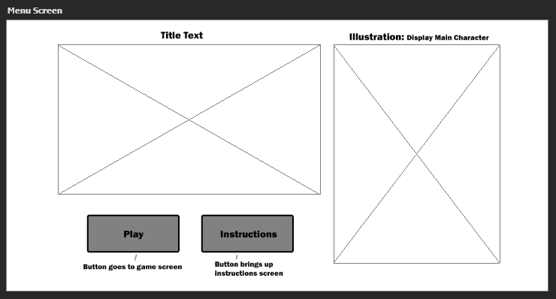

Instructions

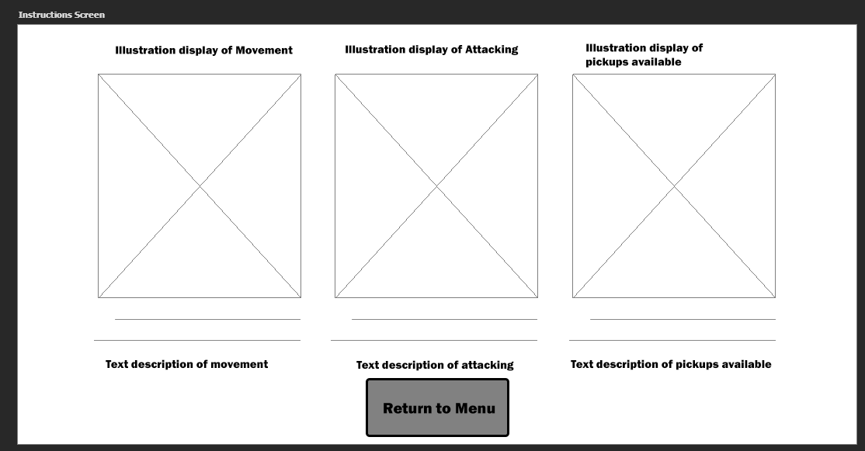

#### Gameplay

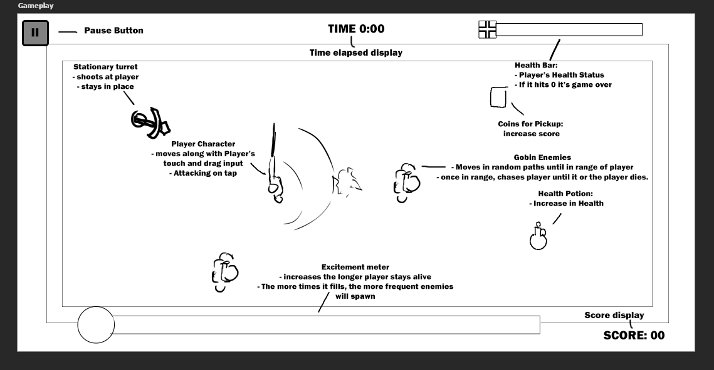

#### Game Over

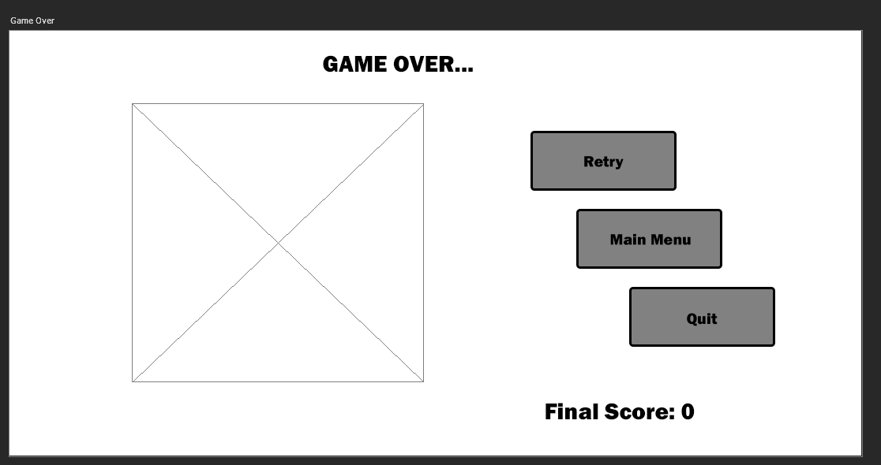

### **Screen Descriptions & Screenshots (Updated)**

* Main Menu: The main menu will have a text title taking up the top left part of the screen, and underneath it 2 buttons to direct the player to either the instructions screen or the in-game level.

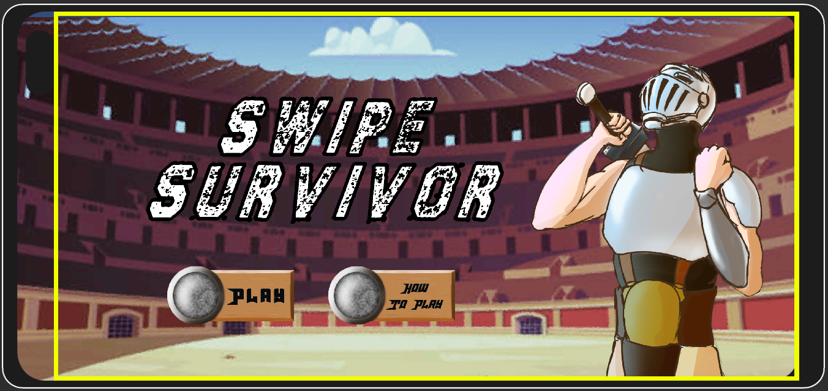

* Instruction Screen: Touching the How to Play button brings up the instruction screen. Illustrations detail the main actions the player can do, from movement, to attacking, to the kinds of items that the player can pick up. The player can return to the main menu by pressing the return button

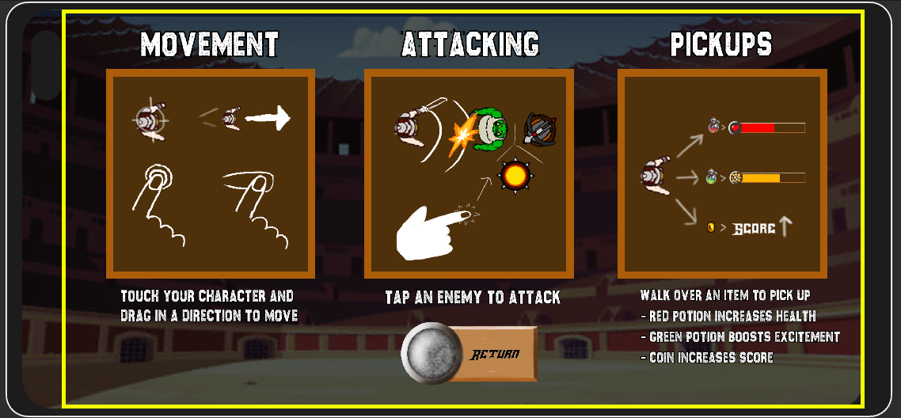

* Level Screen: A singular level constructed via tile map. Enemies and items will spawn over time within the boundaries of the level. A health bar is located on the top right, dictating the player’s health, and an excitement bar is located on the bottom left. The time elapsed is displayed on top of the screen, and the player’s score is located on the bottom right. The Pause button is located on the top left. (**New Image)**

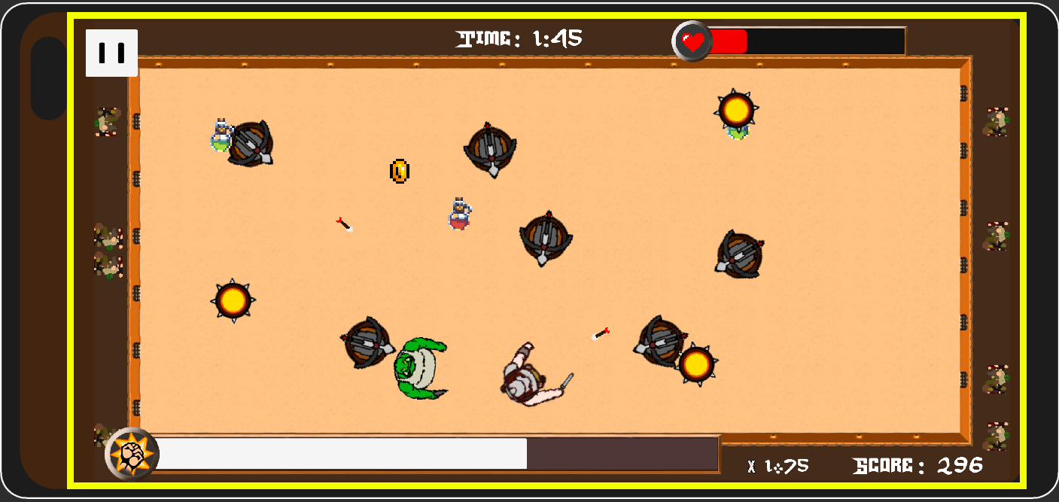

* Game Over Screen: Shown here is an illustration of a defeated warrior. Game Over is emblazoned at the top, and the final score is displayed on the bottom right. To the right of the screen, there are 3 buttons to show if the player wants to restart the level, go to the main screen, or quit the game.

### **Game World**

* The game world takes place in an Amazonian-styled warrior arena. Since time immemorial, the Empire demonstrates their rule by drafting warriors from distant lands in the promises of fame and fortune, otherwise forcing the unwilling to compete for their lives for the entertainment of thousands. You are the latest in their entertainment list, and you’re going to make sure it’s a time to remember.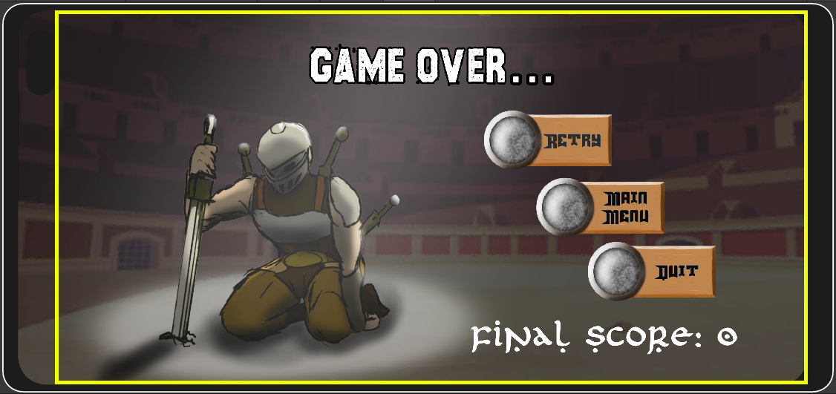

### **Levels (Updated)**

* A singular themed arena that encompasses a majority of the gameplay field.
* Wide open area for the player to move around in as well as becoming populated with enemies that will spawn in at fixed intervals.
* The spawns will become more frequent the longer the player stays alive for
* Spawning logic for the orcs and turrets will be that they’ll show up in the world at random.
* Traps will spawn at any point in the level too.
* Items will randomly spawn in the level as well, depending on different types will boost either the player’s health or score, or increase excitement

### **Characters**

* Warrior: The main player character. Taken by the empire from a moment’s notice, the avatar's main focus is to simply survive. No notion of doubts in his mind and already accepting of the hand fate had dealt him, the avatar will make sure that he takes as many as he can with him.
* Orcs: Standard by-the-dozen orcs captured for arena entertainment use only. Dispensable.

### **Enemies (AI) (Updated)**

* Bouncing drones: Act similarly to bouncing balls around an arena.
* Orc drones: Standard issue enemies. Behaviour is to just simply find a random point on the map to go towards. Once they’ve reached that point, they’ll find another random point to go to. If the player reaches within a certain distance to the drone, they’ll advance towards the player and continue advancing towards the player.
* Turret Drones: These drones usually stay stationary, but will always target the player the moment they spawn into the level.

### **Weapons**:

* Sword: The standard weapon that the player will start off with. Although limited in close-range reach, the player can do a lateral swipe that covers the area in front of them. Generally guaranteed to hit but will place the player at risk by approaching the opponent

### **Scoring**:

* Score will accrue the longer a player can stay alive in the arena.
* Using a multiplier whenever the bar fills up
* Additional score will be awarded to enemies killed.
* Pickups will be placed around the level that can help boost player efficiency such as:
  + Excitement Boost
  + Health Increase
  + Points boost

**Sound Index:**

* Sword swipe
* Arrow shot
* Damage effects
* Coin pickup
* Potion pickup
* Ambient audience

**Music**

* Main Menu: **Prórroga de Tiempo A**
* Game Over: **Ruined Planet**
* Game Level: **Battleship**
* Source: <https://patrickdearteaga.com/arcade-music/>

### **Art/Multimedia Index (Raw files of images):**

* Pixel art styled graphics
* Tile Map for the level

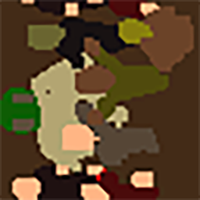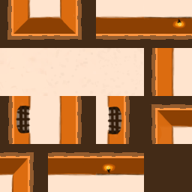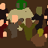

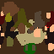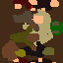

* Main Character/Avatar

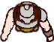

* Main Character spritesheets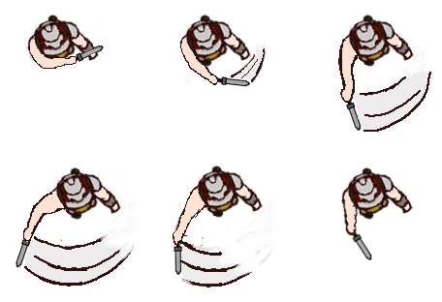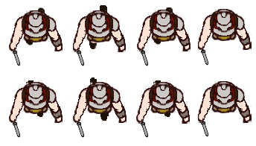

Sword swipe Walking

* Ogre/Goblin enemy

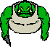

* Stationary enemy/Turret  
  
* Spin Drone/Enemy



* Pickups (Taken from the Unity Asset Store)  
  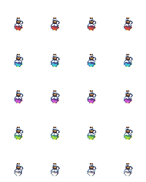
* Score pickup (Taken from the Unity Asset Store)



* Health Bar  
  
* Excitement Gauge
* Button Template (Text implemented within Unity Editor)

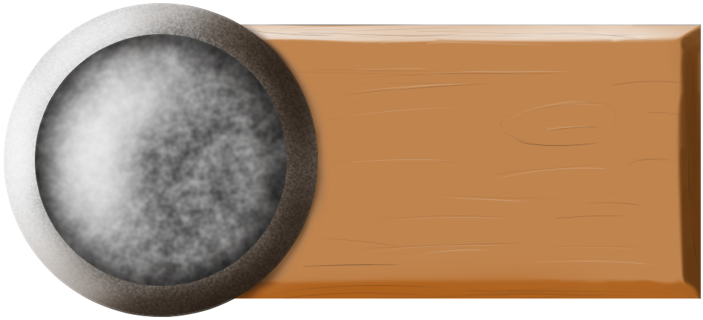

* Arrow



* Background for Start Menu

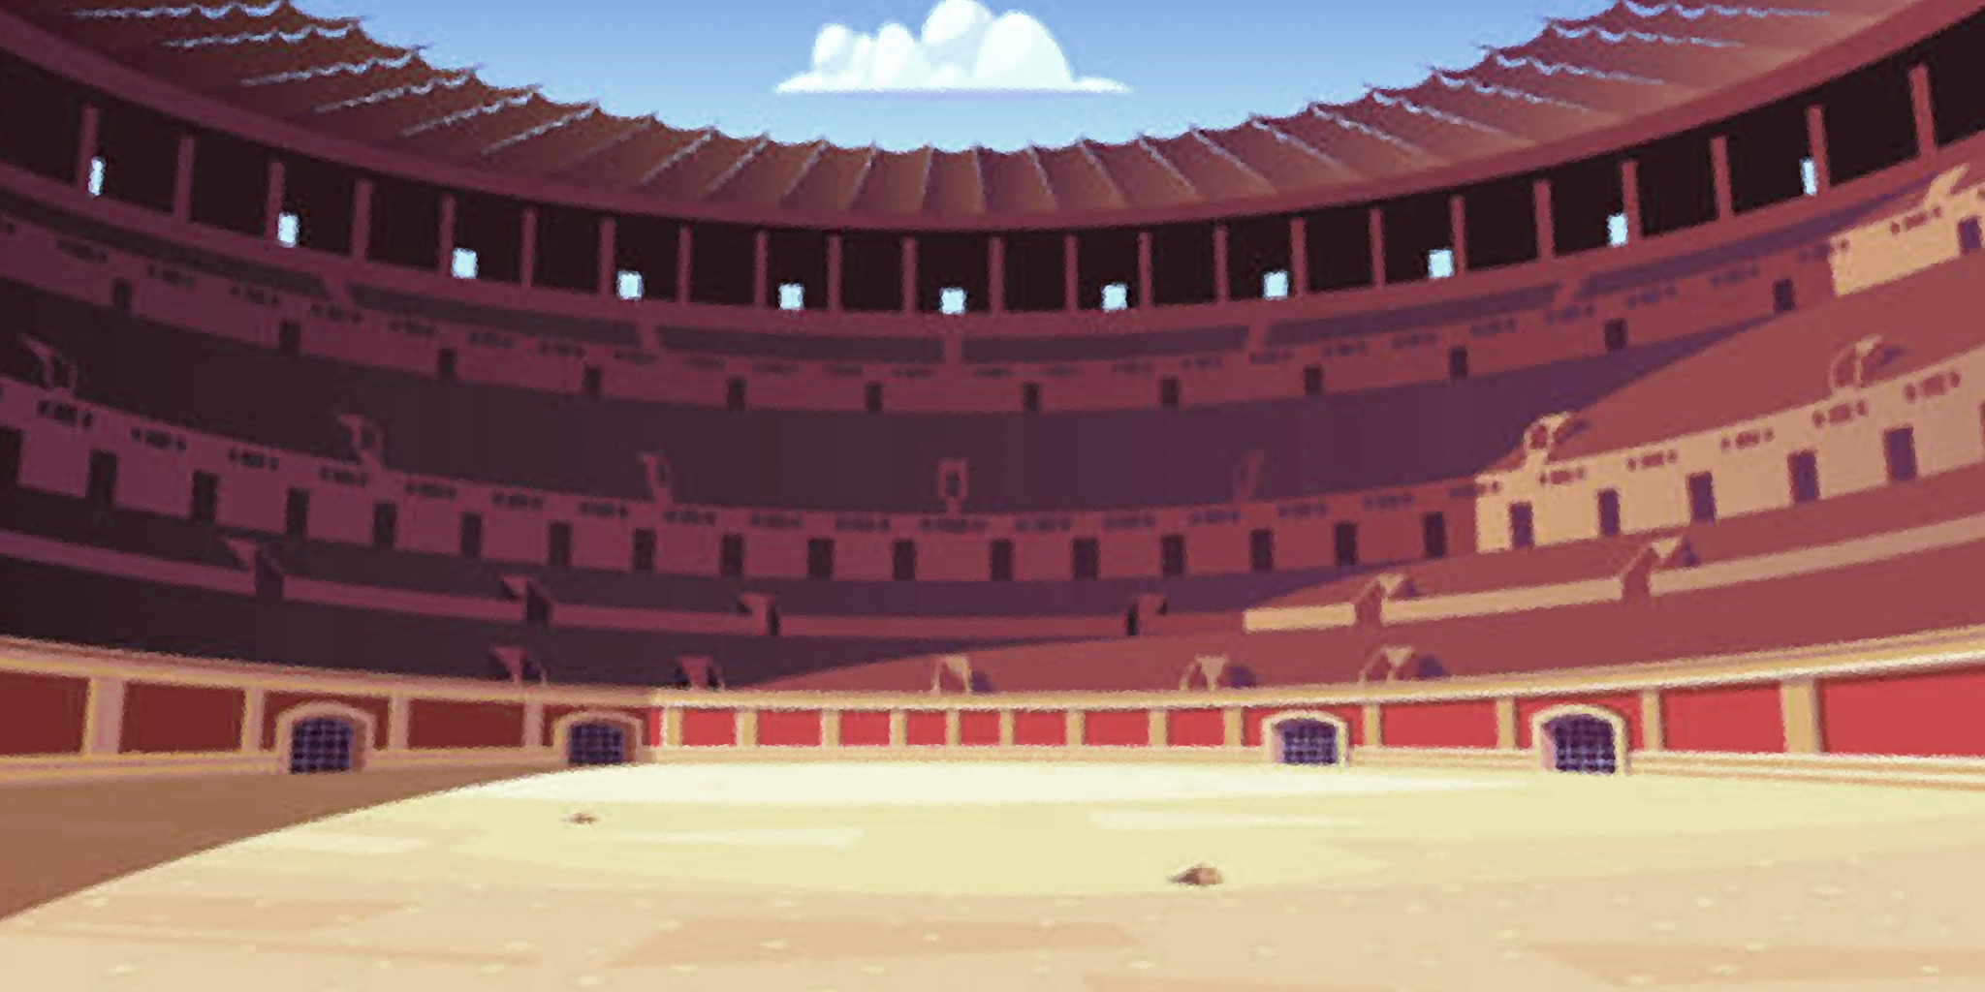

* Avatar Splash art
* 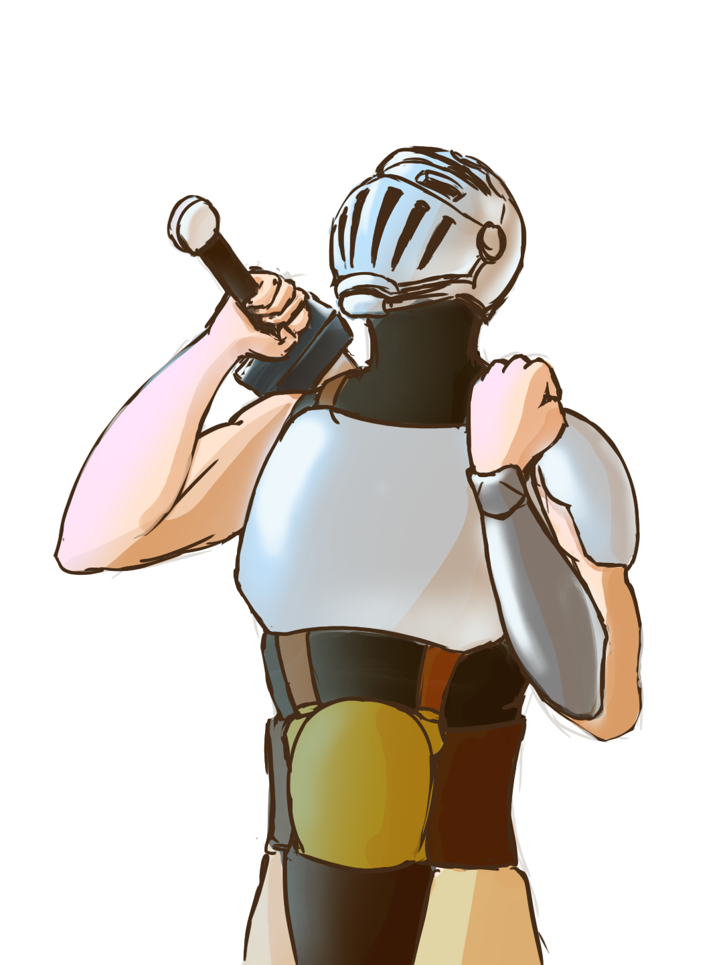
* Avatar Game Over Splash Art
* 